Frequently Asked Questions (FAQ) about this website
SISC Health & Welfare has designed this website to provide a “self-serve” area for district staff to retrieve benefit summaries and benefit booklets for their employees. This allows districts to assemble benefit description packages that they provide to their employees. All documents are saved in pdf format for easy archival and printing needs. This website is intended for district office staff only. It is advised to save the documents to your district website.

What is a Benefit Booklet?
- A benefit booklet provides a complete explanation of benefits, limitations, and other plan provisions which apply to members.

What is a Benefit Summary?
- A benefit summary is a brief overview of the plan’s benefit.

How to select your district’s plan document

- Begin with your district’s Rates-At-A-Glance (RAAG). The description in the parentheses next to the group number will provide information on the medical and prescription drug plans. Remember to select the vendor such as Anthem, Blue Shield, or Kaiser for the medical plan.

Example from the RAAG:
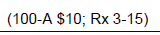

This example is a 100% PPO plan, no deductible, no coinsurance, $10 office visit co-payment. Pharmacy benefit is $3 generic, $15 brand co-payment.

- Select the medical Benefit Booklet based on the medical plan description such as 100-A $10
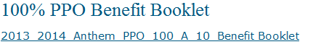
- Select the medical Benefit Summary based on the medical plan description such as 100-A $10.
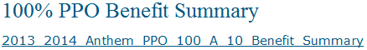
- Select the prescription drug co-pay reference guide based on the prescription drug description such as $3-15.

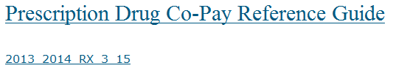

- Select the dental Benefit Highlight under Dental Plan Documents. This example is showing an incentive plan with an annual maximum of $1,500, no orthodontics.
RAAG

Web site link:

- Select the vision plan under Vision Plan Documents based on the RAAG.
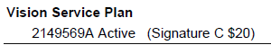

Web site link under Vision Service Plan:

- Riders: See applicable rider section for documents pertaining to OSDP, Chiro, etc.

- Some plans are supported but no longer a marketed plan. See Frozen Plans 2013-2014 from the quick links at the top left of the web page.

